
Low Level Design Part 2 - Implementation Design
{REPLACE THIS BOX WITH THE CUSTOMER LOGO – LEFT ALLIGNED WITH THE PAGE]
IPT - Highways Agencies - Work Package 190
Interim Alarm Management Solution (IAMS)

NetcoolNetcool
Document Approval
Name(s) of those who are approving the document for release.

Alcatel-Lucent Approval |  | Customer Approval
Role |  | Role | N/A
Name | Highways Agency Core Team | Name | N/A

Document History
The purpose of this section is to capture the “baselined” changes made to the content of the document.

Edition | Date | Author | Change note
V0.1 | 07/02/2012 | Anil Gandalla | Initial Draft
Document Location
Location of the document in the Alcatel-Lucent archive

Electronic Location

Table of Contents
1 Introduction 6
1.1 Purpose & Scope 6
1.2 Exclusions 6
1.3 Background 6
1.4 Risks 6
1.5 Assumptions 6
1.6 Issues 6
1.7 Dependencies 7
1.8 Constraints 7
1.9 Links & References 7
1.10 Acronyms & Terms 7
2 General Description 8
2.1 Subsystem Architecture 8
2.2 Subsystem Element Description 9
2.3 Subsystem Function Description 9
3 Implementation Design Traceability 10
3.1 Traceability to Functional Requirements 10
3.2 Traceability to Detailed Design (LLD Part 1) 12
4 Subsystem Common Design 13
4.1 Physical Data Model 13
4.2 Integration Class Design 13
4.3 Physical Interface Design 13
4.4 User Interface Design 13
4.5 Software Class Design 13
4.6 Configuration Design 13
4.7 Component Activity Design 14
4.7.1 Mttrapd Probe 14
4.7.2 De-Duplication 14
4.7.3 Fail Over Automation 14
4.7.4 New network enrichment policy 14
4.7.5 Enddevice event enrichment policy 14
4.7.6 TPR event enrichment Policy 14
4.7.7 Synthetic Alarm Impact Policy 14
4.7.8 Migration Policy 14
4.8 Deployment Node Design 14
5 COTS System Element Design 15
6 Appendices 16

Table of Figures
Figure 1: Netcool Subsystem Structural Diagram 7
Figure 2: IPT Alarm Handling Behavioural Diagram 8

Table of Tables
Table 1: Acronyms and Terms 6
Table 2: Functional Requirement Traceability Matrix 10
Table 3: Detailed Design Traceability Matrix 11

Introduction

Purpose & Scope
This document provides Part 2 of the Low Level Design for Subsystem Netcool. It is the Implementation Design for the Subsystem and describes how the Detailed Design provided in the Low Level Design Part 1 is realized in terms of product and technology choices and their integration.
The High Level Design describes the delta system required to fulfil Work Package 190. The Low Level Design, Parts 1 & 2 details the delta for Subsystem Netcool.
This document describes an Implementation Design such that the development team has sufficient information to identify the required COTS products, understand how they integrate together and what customization and configuration is needed, in order to build Subsystem Netcool.
This document identifies which Functional Requirements are fulfilled by the Implementation Design and specifically, which sections of the design fulfil which requirements, to a granular level. Similarly, it identifies which parts of the Implementation Design fulfil or ‘realize’ which parts of the Detailed Design (as captured in the Low Level Design Part 1), again to a granular level. The granularity is such that it reduces each aspect of the design to an atomic level. For instance, the process design identifies a set of processes, such that it is possible to trace each process to one or more Functional Requirement and to one or more Detailed Design processes that it fulfils/realizes.
The structure of the document hereafter is fourfold: one, a general description of the subsystem architecture; two, a traceability of the Implementation Design to requirements and the Detailed Design; three, the common, Subsystem wide design; and four, the COTS product specific design.
Refer IPT HLD [R1] for the specific functional scope of the Subsystem changes in the context of the Work Package

Exclusions
- PC Relationships are out of scope

Background
Refer IPT HLD [R1].

Risks
- Alarm handling rules may misbehave, if correct IPT Mibs are not available for development.
- Alarm mapping may be erroneous, if correct raw captures from NEs are not available for development.
- Erroneous Population of topology data in Circee may result in wrong alarm mappings.
- Deduplication trigger may perform erroneous, if proper validation is not done.

Assumptions
- Relevant IPT mibs are shared with development team
- Updated Circee table schemas, templates, service types are available in Circee.
- IPT topology data, STI_IDs are populated error free in Circee.

Issues
- Actual Raw captures from NEs is to be available.

Dependencies
- Updated CIRCEE tables is available in Circee.
- Updated Topology data is available in Circee.

Constraints
N/A

Links & References
- High Level Design WP190 IPT - Circee and IAMS.doc
- GYSRGDSSP0007_R08 PS-DS036-07 FUNCTIONAL SPECIFICATION NETCOOL

Acronyms & Terms

APTR | All Purpose Trunk Roads
HA | Highways Agency
HLD | High Level Design
IAMS | Interim Alarm Management Solution
IPT | IP Translator
IPTNEM | IP Translator Network Element Manager
NRTS | National Road Transport Systems
OSS | Operational system support
QDT | Quinton Data Team
PDAT | Performance Data Analytical Tool
PTZ | Pan, Tilt and Zoom
RMD | Roadside Multiple Diversity
SCR | Service Credits Regime
SDP | Service Delivery Point
SoR | Schedule of Requirements
SPC | Service Provision Capability
SSL | Simulation Systems Ltd.
ST | Service Type
STI | Service Type Instance
WP | Work Package
Table 1: Acronyms and Terms

General Description
The implementation details of Work Package 190 are based on the Netcool subsystem features described in HLD [R1]. Alarms from IPT/IPTNEM are handled by inventing new IPT rules and updating Netcool Mttrapd rules and IPT Lookups. NOC users are able to view IPT alarms from different WebGUI views based on specific alarm criteria mentioned in the filter conditions. Impact Policies enrich IPT alarms from the data available in CIRCEE data base.

Subsystem Architecture
A brief overview of Netcool subsystem architecture is depicted below. Highlighted sub elements which are updated or invented as part of work package and Interaction between Low level components in Netcool subsystem is shown in the structural diagram below.
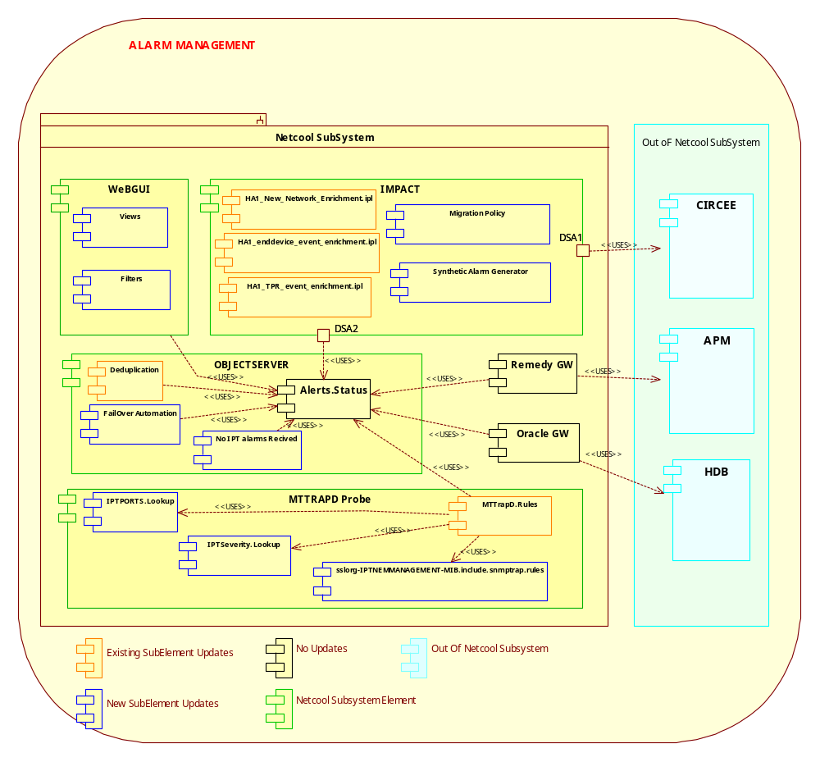
Figure 1: Netcool Subsystem Structural Diagram

Below Activity diagram depicts the IPT alarm handling by probe rules and object server automations in the netcool subsystem

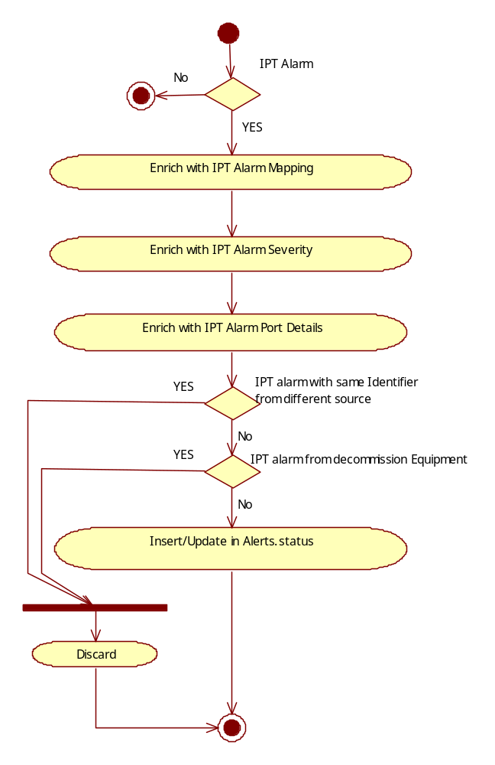
Figure 2: IPT Alarm Handling Behavioural Diagram

Subsystem Element Description
Refer [R2].

Subsystem Function Description
Refer [R2].

Implementation Design Traceability

Traceability to Functional Requirements

Functional Requirement Reference | Description | Compliancy -Implementation Design, Feature Name | Compliancy -Implementation Design, Section Reference | Compliancy Level (Full / Partial)
FR521 | Clears and de-duplication shall continue on the alarm management system after any IPT NEM restart. | Deduplication | 4.7.2
FR522 | Clears and de-duplication shall continue on the alarm management system after any alarm management restart. | Deduplication | 4.7.2
FR558 | The solution will allow users to display all underlying alarms for any synthetic STI failure alarm | Synthetic Alarm Tool | 4.4.2
FR560 | The solution will correlate clear and raise alarms for scenarios where the raise alarms have been de-depulicated
FR561 | The solution will correlate clear and raise alarms for scenarios where the raise alarms have not been de-duplicated
FR524 | Where all end-devices supporting a single STI are unreachable, the end-device alarms shall be correlated into a single service affecting synthetic alarm. | Synthetic Alarm Impact Policy | 4.7.8
FR525.1 | A single service affecting synthetic alarm will be enriched with the details and number of affected STI's.
FR525.2 | All underlying affected end devices/synthetic alarms should be viewable by the Alarm Management system user. | IPT alarm Filter and views | 4.4.1
FR525.3 | These underlying end devices/synthetics wont be sent to the Problem Management system.
FR527 | A view displaying only IPT alarms shall be created for the NOC. | IPT alarm Filter and views | 4.4.1
FR528 | A view shall be created in the fault management system to display IPT power alarms for NRTS owned devices. | IPT alarm Filter and views | 4.4.1
FR536 | A view displaying IPT Service Affecting alarms shall be created for the NOC. | IPT alarm Filter and views | 4.4.1
FR531 | The alarm management system shall display the IPT alarms as defined in the alarm list.
FR562 | A webtop view displaying multiple STI affecting alarms shall be created for the NOC. | IPT alarm Filter and views | 4.4.1
FR563 | A webtop view displaying single STI affecting IPT alarms shall be created for the the NOC | IPT alarm Filter and views | 4.4.1
FR507 | The existing "new build" enrichment process will be applied to the IPT Device alarms.
FR515 | The alarm management system shall display the impacted STIs and SDP Location for each Service Impacting IPTNEM event.
FR516 | All service affecting alarms from the IPTNEM shall display how many end-devices are affected.
FR519 | Alarms shall be enriched with details showing the power landlord of the cabinet in which the asset is located.
FR555 | For each end device event, the TCP Port will be enriched from a Netcool lookup table | MTTrapd | 4.7.1
FR556 | For end device and any synthetic alarms, the solution will enrich the alarm with the source IPT geographic address
FR501 | The Netcool SNMP Probe shall receive SNMP traps from IPTNEM to report alarms/events that are specific to it and IPT Devices. | MTTrapd | 4.7.1
FR502 | The Netcool SNMP Probe shall map the trap fields to the Netcool event fields. | MTTrapd | 4.7.1
FR503 | The solution shall mark an alarm as requiring NOC action based on information in the alarm list. | MTTrapd | 4.7.1
FR510 | The alarm summary field will contain descriptive information to allow the NOC to understand the effect of the fault. | MTTrapd | 4.7.1
FR512 | The alarm management system shall display, for each IPTNEM event, whether event type is Signals or Midas.
FR517 | The solution shall display to the NOC a failure of communication between an IPT and the Local Communications Controller (LCC).
FR567 | Duplicate alarms should be discarded irrespective of source
FR568 | Unique alarms from either IPTNEM instance will be captured and displayed in the fault management system | Fail over automation | 4.7.4
FR569 | The solution will notify the NOC when there has been a 5 minute gap in receipt of IPT alarms
Table 2: Functional Requirement Traceability Matrix

Traceability to Detailed Design (LLD Part 1)

Not Applicable.

Detailed Design (LLD Part 1) Feature Name | Detailed Design (LLD Part 1) Section Reference | Compliancy -Implementation Design, Feature Name | Compliancy -Implementation Design, Section Reference | Compliancy Level (Full / Partial)
Table 3: Detailed Design Traceability Matrix

Subsystem Common Design

Physical Data Model
Updates to VIEW_ASSET_NETCOOL table, Physical Database Schema detailed design, support to new templates and new service type are defined in Circee subsystem Low Level Design.

Integration Class Design
Not Applicable

Physical Interface Design
Not Applicable

User Interface Design
WebGUI Filters, Views updates and screenshots are specified here at later versions

IPT alarm Filter and views
- All_STI_impacted_alarms
- All_Signal_and_MIDAS_end_device_unobtainable_alarms
- All_nonservice_affecting_IPT_alarms
- All_Power_Alarms

Synthetic Alarm Tool

Tool to display all end device alarms which are related to the STI failure.
Code Changes to policy will be updated here in later version of the doc..

Software Class Design
Not Applicable

Configuration Design
Not Applicable

Component Activity Design
The Component Activity Design can be provided in one of a number of ways, e.g. pseudo-code, UML Activity Diagrams or BPMN diagrams.

Mttrapd Probe
Code Changes to policy will be updated here in later version of the doc..

De-Duplication
Code Changes to policy will be updated here in later version of the doc..

No IPT alarms received
Code Changes to policy will be updated here in later version of the doc..

Fail Over Automation
Code Changes to policy will be updated here in later version of the doc..

New network enrichment policy
Code Changes to policy will be updated here in later version of the doc..

Enddevice event enrichment policy
Code Changes to policy will be updated here in later version of the doc..

TPR event enrichment Policy
Code Changes to policy will be updated here in later version of the doc..

Synthetic Alarm Impact Policy
Code Changes to policy will be updated here in later version of the doc..

Migration Policy
Code Changes to policy will be updated here in later version of the doc..

Deployment Node Design
Not Applicable.

COTS System Element Design
Not Applicable.

Appendices

End of document

